|  |  |  |
| --- | --- | --- |
|  | **CHAROTAR UNIVERSITY OF SCIENCE & TECHNOLOGY**  **DEVANG PATEL INSTITUTE OF ADVANCE TECHNOLOGY AND RESEARCH** | D:\Admin\coursefile\Depstar-final-logo (1).jpg |

# Weekly Report

*In this report, students require to mention the work that has been done during the week and planning for the next week. (Please fill individual reports for each week)*

|  |  |
| --- | --- |
| **Student ID: 20DCS083** | **Student Name: Naitik Patel** |
| **From Date: 30/05/22** | **To Date: 03/06/22** |
| **Semester: 5th** | **Internship ID:** |

**Week-3**

**Domain: Web development**

**Technology: ReactJS**

**Work done last week (Attach supporting Documents):**

* **30/05/2022 (Monday)**

Fetch the data from an API that is given here and store the data into a table in a good manner. also used the map method to combine the data with table format.

<https://jsonplaceholder.typicode.com/users>

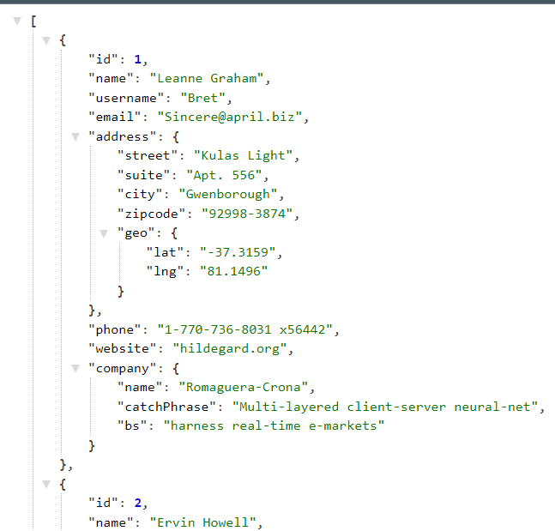

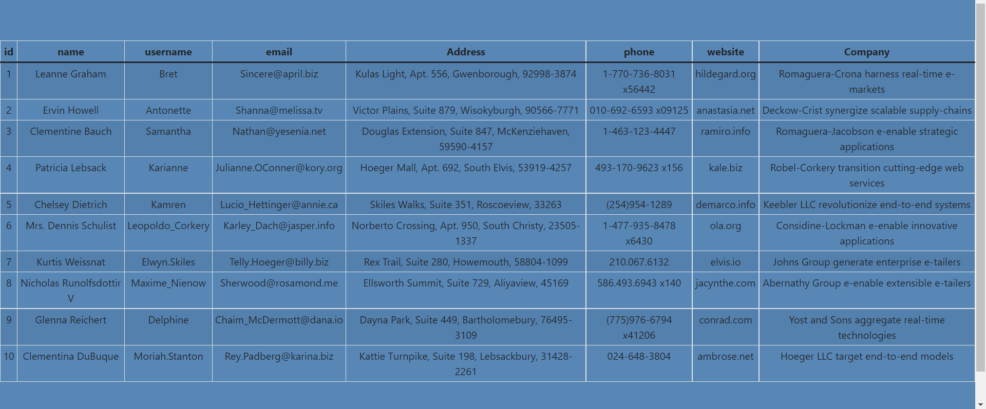

* **31/05/2022 (Tuesday)**

Added search tool to get efficient data. Here In the dropdown user can select any column and search for the value of that column and only matching data will be represented.

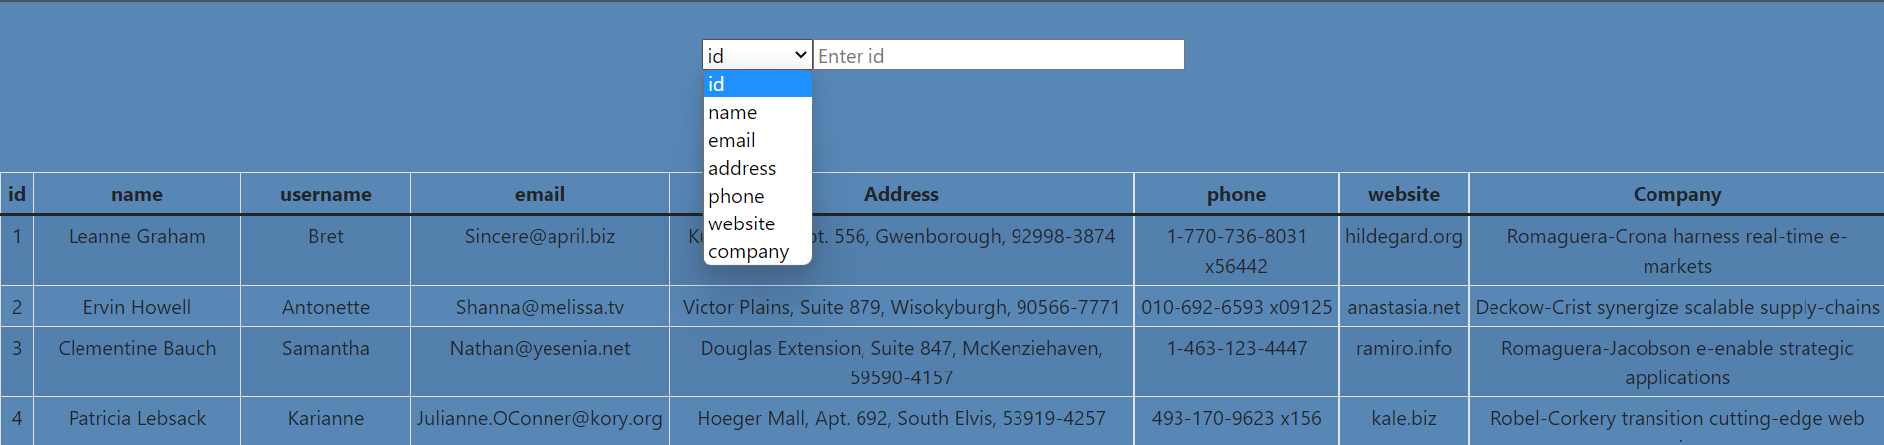

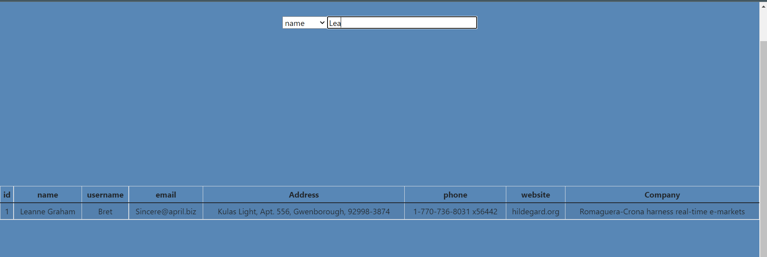

* **01/06/2022 (Wednesday) & 02/06/2022(Thursday)**

Created a News website using ReactJS & MUI.

* Created a news app using newsapi.org.
* Added different categories in a news app.
* Learn how to fetch a large number of data from popular APIs.
* Used MUI for navigation bar and cards.
* I made this completely responsive.
* I used react-router-dom for the navigation bar.

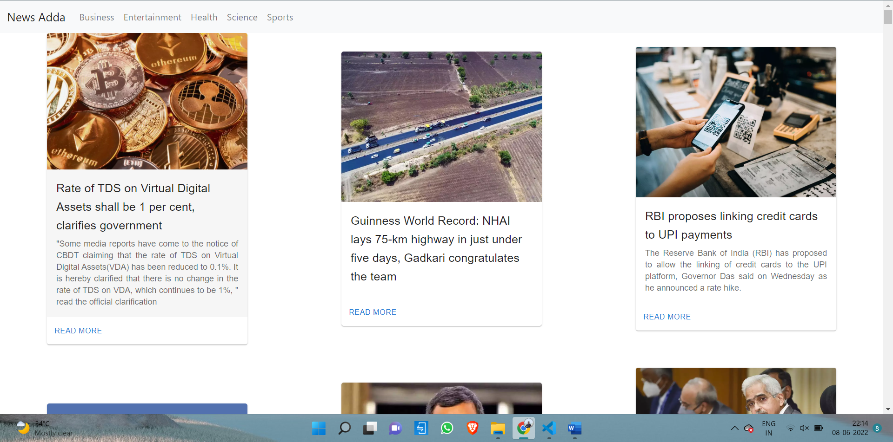

* **03/06/2022 (Friday)**

Learn About Dynamic routing

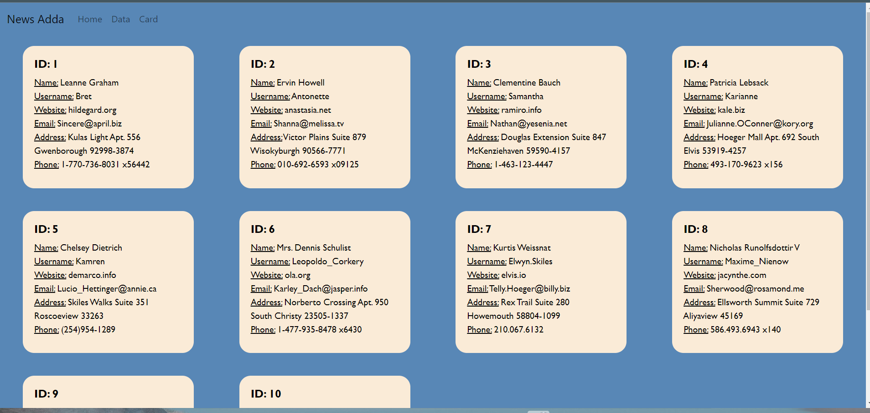

**Plans for next week:**

To learn State management methods.

## References:

<https://newsapi.org/>

<https://reactjs.org/docs/hooks-state.html>



## Signature of External Guide Signature of Internal Guide